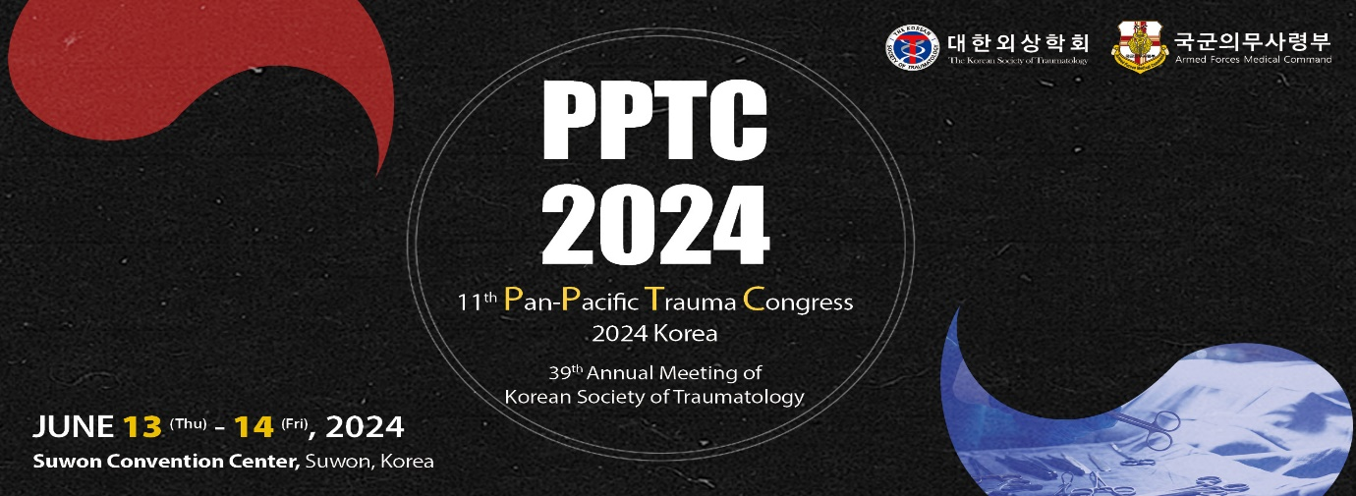
11th Pan-Pacific Trauma Congress 2024 Korea
Cancellation Request
( Before the Registration Deadline )

Please fill out this form and send it to the secretariat of PPTC 2024 via email.
(trauma@kams.or.kr)

Name
Affiliation
Payment Method
Date
Registration Fee
Card / Remitter
Account No.
Bank Name

Reimbursement can be possible before the registration deadline.
If the deadline is extended, reimbursement period would also be extended.
Please note that refund would be made after the congress is over.

